**How to use QComboBox - An Example**

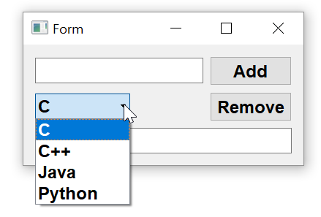

**Step 1**

**Adding the widgets to the form**

In following example, there are two horizontal layouts and a LineEdit control placed on a form with vertical layout. In upper horizontal layout, another lineedit widget t1 and a push button b1 are added. In second horizontal layout, a QComboBox widget combo1 and another button b2 are dropped. The bottom text box is named as t2.

1. To add items in the combo box select it and right click on it. From the resulting popup menu, choose edit items and add items by pressing + button
2. Save the form as combo.ui and generate its Python script by pyuic5 utility.

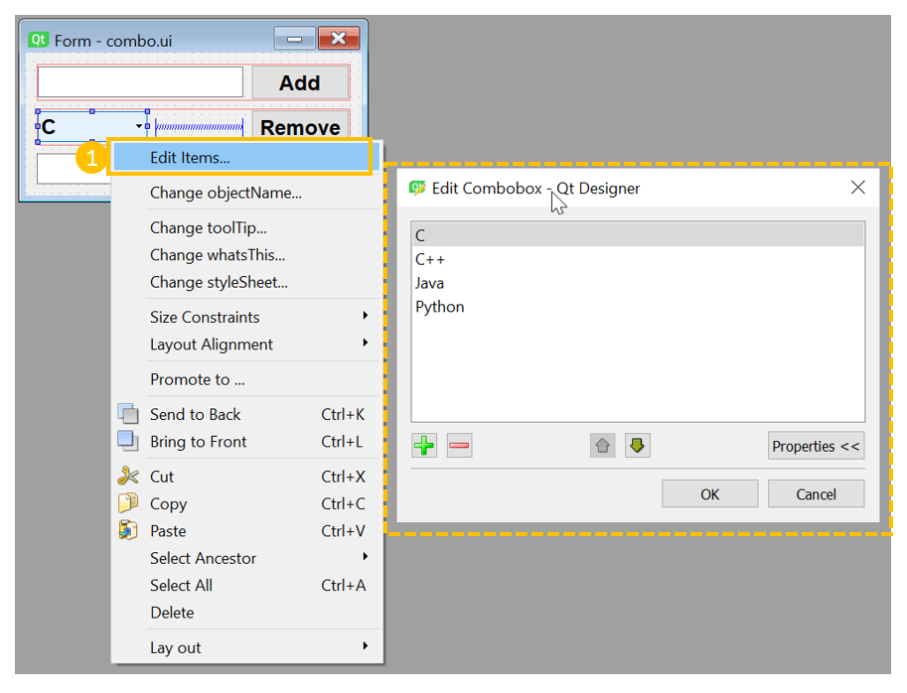

**Step 2**

**Event Handling**

1. Open combo.py with IDLE. Add following methods to Ui-Form class

**def rmitem(self):**

**indx=self.combo1.currentIndex()**

**item=self.combo1.currentText()**

**self.t2.setText(item+" is removed from combobox")**

**self.combo1.removeItem(indx)**

**def additem(self):**

**self.combo1.addItem(self.t1.text())**

**self.t2.setText(self.t1.text()+" is added to combobox")**

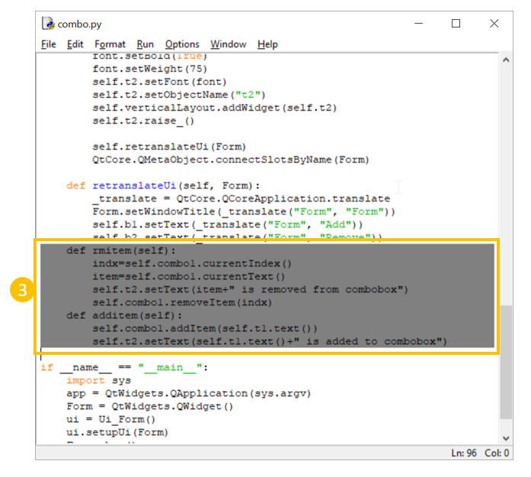

1. Use these methods as signals for clicked signal of b2 and b1 buttons respectively by adding following statements in setupUi() method

**self.b2.clicked.connect(self.rmitem)**

**self.b1.clicked.connect(self.additem)**

